✴

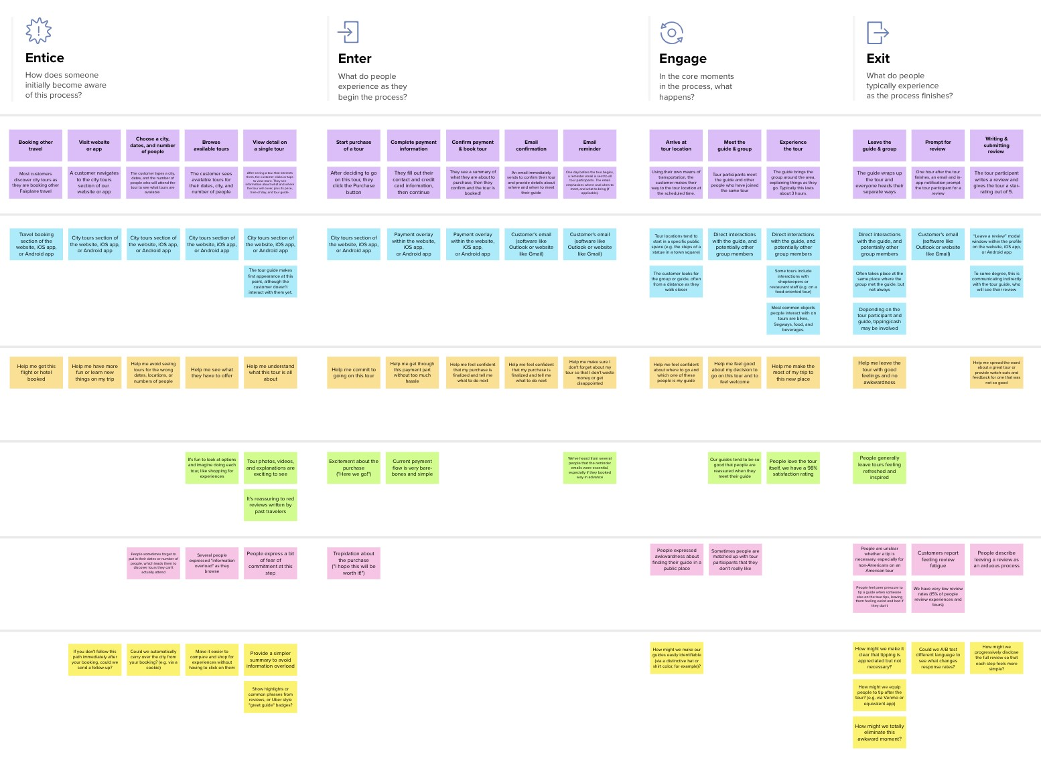

**Template**



**Document an existing experience**

**TIP**

As you add steps to the experience, move each these “Five Es” the left or right depending on the scenario you are documenting.

Narrow your focus to a specific scenario or process within an existing product or service. In the **Steps** row, document the step-by-step process someone typically experiences, then add detail to each of the other rows.

Customer experience journey map

|  |  |  |  |  |  |
| --- | --- | --- | --- | --- | --- |
| **SCENARIO**  **Browsing, booking, attending, and rating a local city tour** | **Entice**  How does someone initially become aware of this process? | **Enter**  What do people experience as they begin the process? | **Engage**  In the core moments in the process, what happens? | **Exit**  What do people typically experience  as the process finishes? | **Extend**  What happens after the experience is over? |
| **Steps**  What does the person (or group) typically experience? | **The web app Customer can get**  **contains all the the details of the details of the donor by registering plasma donor in the web app**  Customer can view all the available information of the plasma donor | **Registering in the**  **platform by** A remainder mail  **providing the** should be sent to the  **required details** donor | **The donor uses their Tho donation**  **mode of transportation process should be Donating plasma at**  **to arrive at the hospital explained to the the designated time**  **at the appointed time. donor and location** | **One hour following the The donor typically rests plasma donation, the following the procedure donor receives an email because they have and an app notice asking provided plasma.**  **for feedback.** | **Both the donor as well With the experience**  **as receiver should shared by them it**  **share theor experience might be a great**  **with others useful for others** |
| **Interactions**  What interactions do they have at each step along the way?  **People:** Who do they see or talk to?  **Places:** Where are they?  **Things:** What digital touchpoints or physical objects would they use? | The people in Plasma receiver also demand ask their search in social friends and families media by advertising  their need  Customer also search in blood banks and nearby hospitals | Within the website's Software website  iOS or Android app, like Outlook or  there is a verification website like Gmail  of donor overlay. can be used | Donor directly Interactions can also  interect with the be done through  doctor mobile phones and  websites | **Use of email following a donation** | **Examining the By interacting with**  **feedback they offered the past donor**  **in the feedback section others will be able**  **and on social media to know the process** |
| **Goals & motivations**  At each step, what is a person’s primary goal or motivation? (“Help me...” or “Help me avoid...”) | Providing easy Helping the receiver access to the by providing user  receiver friendly platform | The eligibility of the The donation donor should be process should be  known to the people transparent | Assist in making the  The demand of the donor and consumer  plasma should be feel happy and  known to the donor welcomed | **Help the donor feel satisfied as they leave the hospital** | **Customer should be satisfied by donating plasma** |
| **Positive moments**  What steps does a typical person find enjoyable, productive, fun, motivating, delightful, or exciting? | User friendly platform and overview can be get easily | Donor should be happy that they are able to donate | Inorder to know the full details of the donation process they can contact the helpline | The donor is more at ease knowing that you can save a life. | To spread the word about the advantages of plasma donation |
| **Negative moments**  What steps does a typical person find frustrating, confusing, angering, costly, or time-consuming? | Lack of awareness of the website | Authentication should be filed as it is related to the life of a person | The user might be anxious that their data might get hacked | Following donation, the donorr could feel nervous | Further notification following plasma donation should be provided to the donors |
| **Areas of opportunity**  How might we make each step better? What ideas do we have? What have others suggested? | Advertising in the COntacting friends social media and families | Customer should be able to easily register into the platfprm and the process should be transparent | The customer should be notified of the unfortunate situations in which the donor might not be able to donate | Proper customer service should be given to make them feel at ease | Feedback section should be included so that all the needs of the customer can be fulfilled |

Use this framework to better understand customer needs, motivations, and obstacles by illustrating a key scenario or process from start to finish.



When possible, use this map to document and summarize interviews and observations with real people rather than relying on your hunches or assumptions.



Created in partnership with



[**Share template feedback**](https://muralco.typeform.com/to/CiqaHVat?typeform-source=app.mural.co)



**Need some inspiration?**

See a finished version of this template to kickstart your work.

[**Open example**](https://app.mural.co/template/f59f644b-b4b4-47b5-9ed6-3a8c71ceb612/896b31fe-5597-40ef-9b06-3811a1a45ace)

|  |  |  |  |  |  |  |  |  |
| --- | --- | --- | --- | --- | --- | --- | --- | --- |
|  |  |  |  |  |  |  |  |  |
|  |  |  |  | |  |  |  |  |

|  |  |  |  |  |  |  |  |  |
| --- | --- | --- | --- | --- | --- | --- | --- | --- |
|  |  |  |  |  |  |  |  |  |
|  |  |  |  | |  |  |  |  |